**Mockup UI**

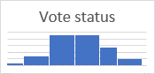



50

20

VOTE

VOTE

VOTE

…

Hotel 2

Hotel 1

Home Vote About Us Contact

Hotel Voting System

X